1.CHECKING ALL TYPES

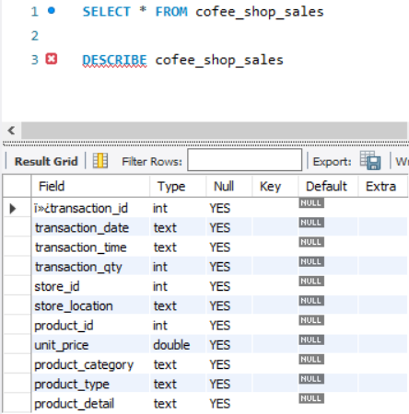

2.transaction_date COLUMN IN TEXT CONVERT IT IN DATE DD/MM/YYYY

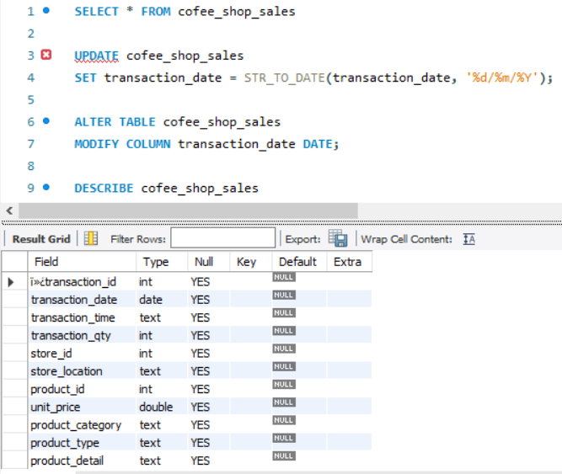

3.transaction_time COLUMN TEXT TO TIME

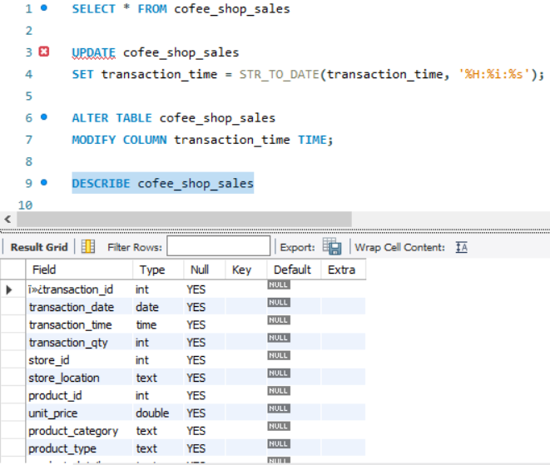

4. CHANGING COLUMN NAME I>>?transaction_id TO transaction_id

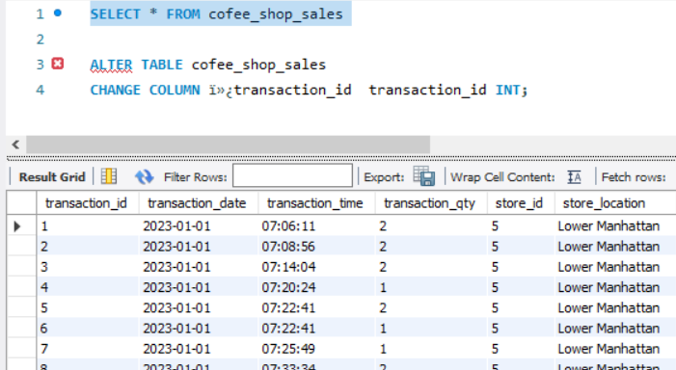

A. TOTAL SALES ANALYSIS

1 CALCULATE THE TOTAL SALES FOR EACH RESPECTIVE MONTH

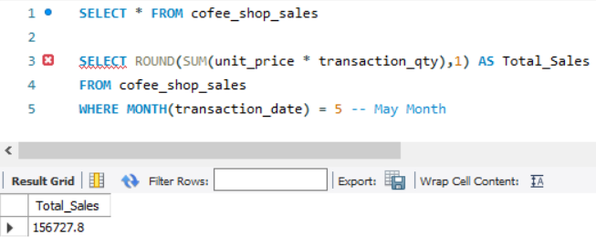

2 DETERMINE THE MONTH-ON-MONTH INCREASE OR DECRESE IN SALES

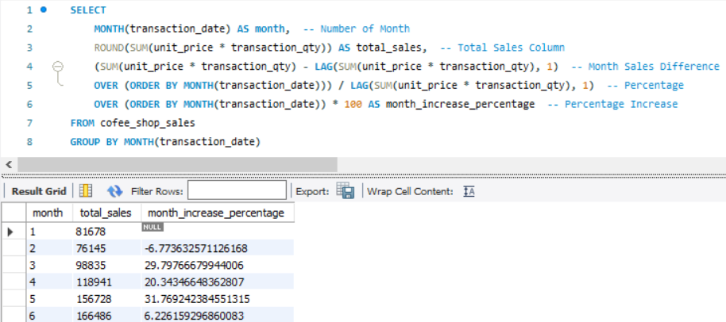

3 TOTAL QUANTITY SOLD

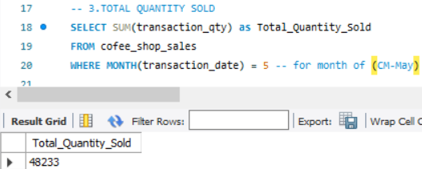

B. Total Order Analysis

4 Calculate the total number of orders for each respective month.

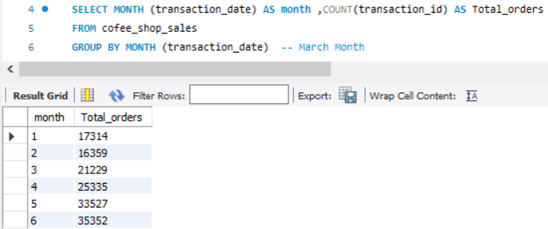

5 Determine the month-on-month percentage increase or decrease

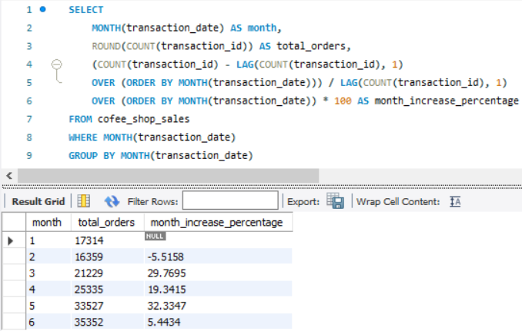

C Total Quantity Sold Analysis

6.1 Calculate the total quantity sold for each respective month. With percentage increase or descrease

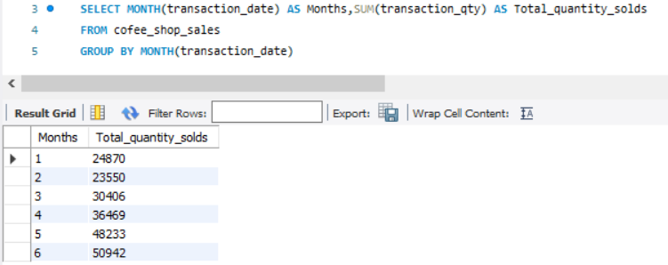

6.2

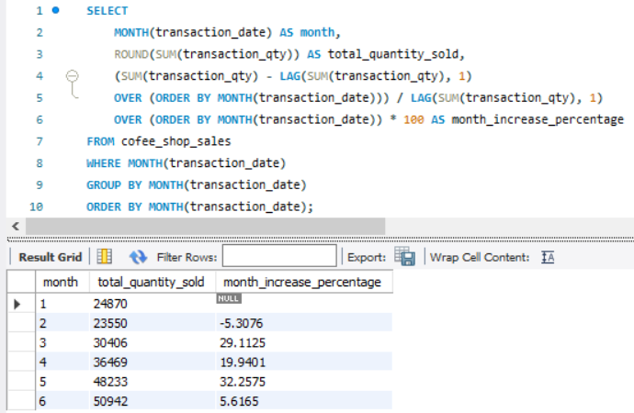

D Charts requirements

7 Display detailed metrics (Sales , Orders , Quantity) DAILY

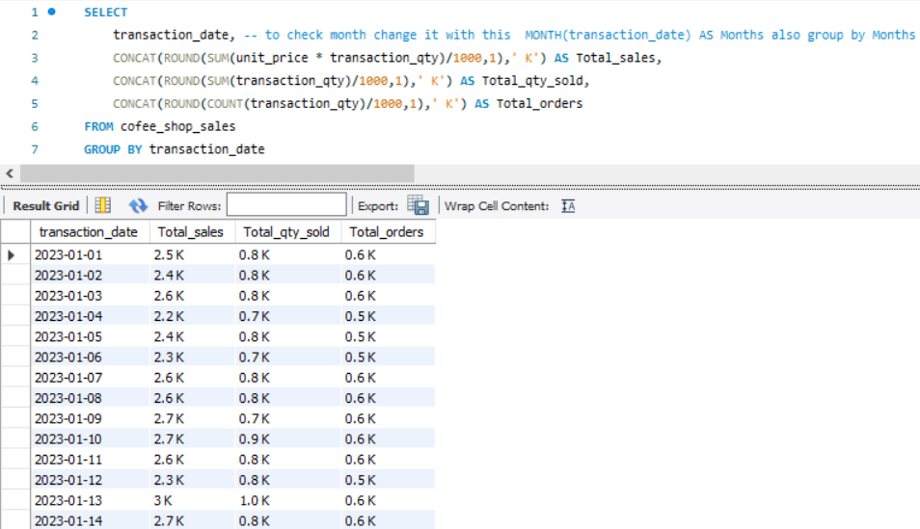

8 Sales Analysis by Weekdays and Weekends

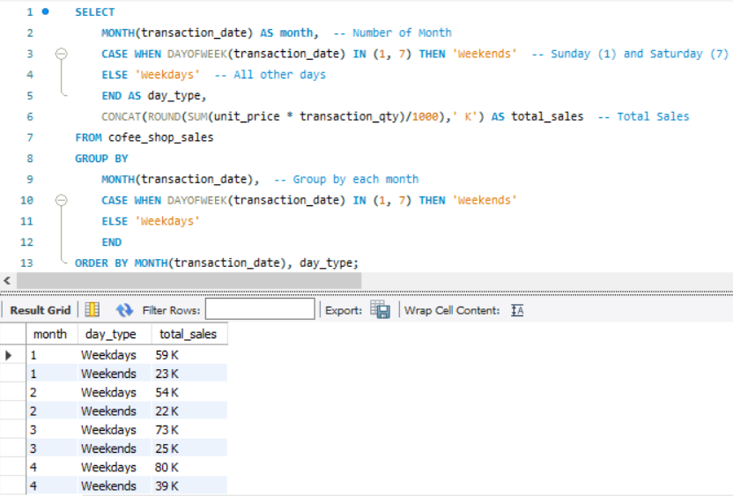

9 Sales Analysis by Store Location

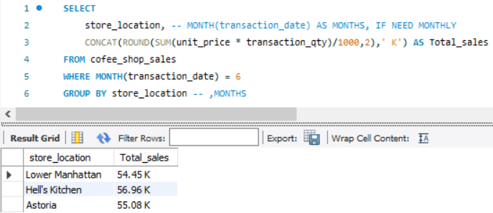

10 Daily Sales Analysis With Average Line

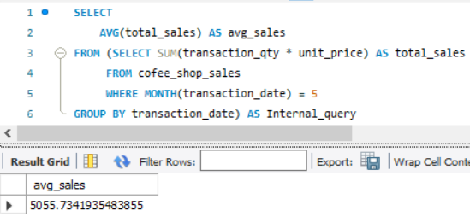

***Query Explanation:***

* This inner subquery calculates the total sales (unit_price * transaction_qty) for each date in May. It filters the data to include only transactions that occurred in May by using the MONTH() function to extract the month from the transaction_date column and filtering for May (month number 5).
* The GROUP BY clause groups the data by transaction_date, ensuring that the total sales are aggregated for each individual date in May.
* The outer query calculates the average of the total sales over all dates in May. It references the result of the inner subquery as a derived table named internal_query.
* The AVG() function calculates the average of the total_sales column from the derived table, giving us the average sales for May.

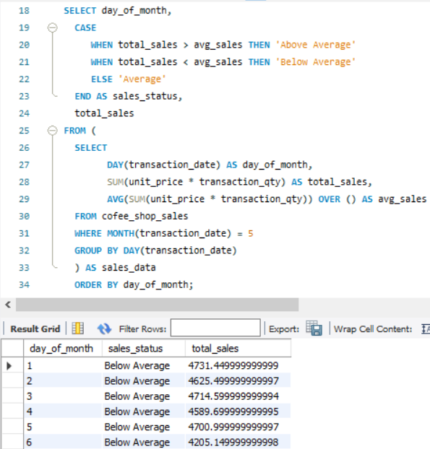

11 Sales Analysis by Product Category

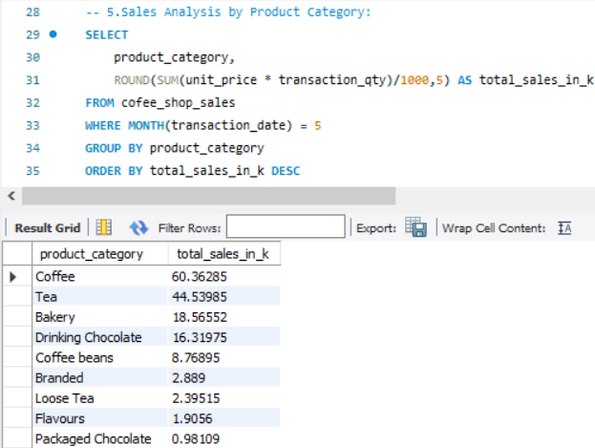

12 Top 10 products by sales

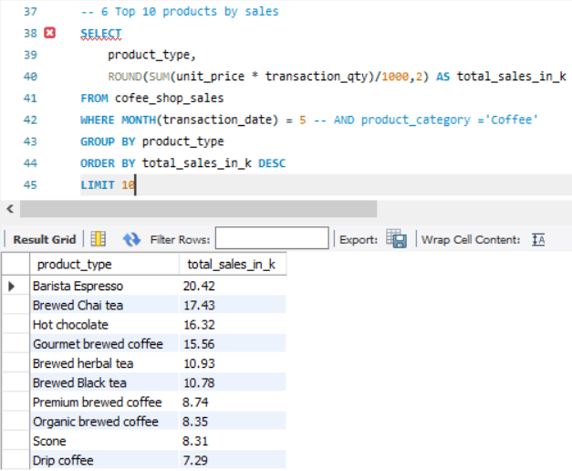

13 Sales Analysis by Day and Hour

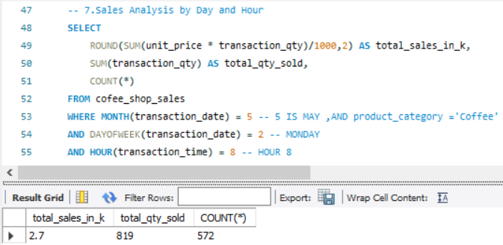

14 Sales Analysis by Hour

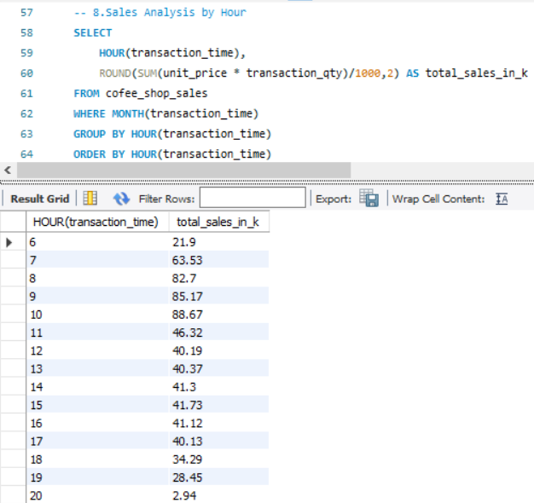

15 The total sales for each day of the week for the selected month

